Churchwardens’ Annual Church Property Report – 2020/2021
‘Go up to the hills and bring wood and build the house, so that I may take pleasure in it and be honoured, says the Lord.’ Haggai 1.

In accordance with The Parish Administration Act (2010) and good stewardship, the Template below is to be:
- completed and signed off on by the Churchwardens;
- presented to Parish Council ahead of budget deliberations for the following year (suggest September each year)
- forwarded by 31 December 2020; and
- presented at the following Annual Parish Meeting.

Presented to Parish Council: ______ / ______ / ___________ (Date)
To be presented to Annual Parish Meeting: ______ / ______ / ___________
Sent to Registry: ______ / ______ / ___________

This form should be considered when considering your annual parish budget, especially the maintenance budget.
Note that all issues identified DO NOT need to be addressed at once, create a plan to annually inspect and repair the roof, clean the guttering & then highest risks first.

Save $5,000 excess on certain claims!
See Page 5 of this document!

Parish/Centre |  | Year
Street address |  | 2020/2021
Building

Complete visual inspection and tick / insert comments or rating where appropriate
(one report per building):

External
 | No visible problem | Further Inspection Required | Work to be undertaken | When will action be taken? | Risk rating
Roof
Guttering
Windows / Doors
Walls
Ground level perimeter
Steps/Ramps/Handrails
Land and gardens
Other (eg garden)
Other

Internal
 | No visible problem | Further Inspection Required | Work to be undertaken | When will action be taken? | Risk rating
Ceiling
Walls
Windows / Doors
Floor / Flooring
Furniture
Handrails
Other (eg handbasin)
Other -

Notes: Nature of required work: ____________________________________________________________________________________________________
Notes: Timeline of required work:___________________________________________________________________________________________________
Churchwardens Signatures
Name Signature Date
__________________________ ________________________ ____/____/_____
__________________________ ________________________ ____/____/_____
__________________________ ________________________ ____/____/_____
Provision in Parish Budget: Yes / No (Year:__________)

Estimated Cost of work required: ___________________

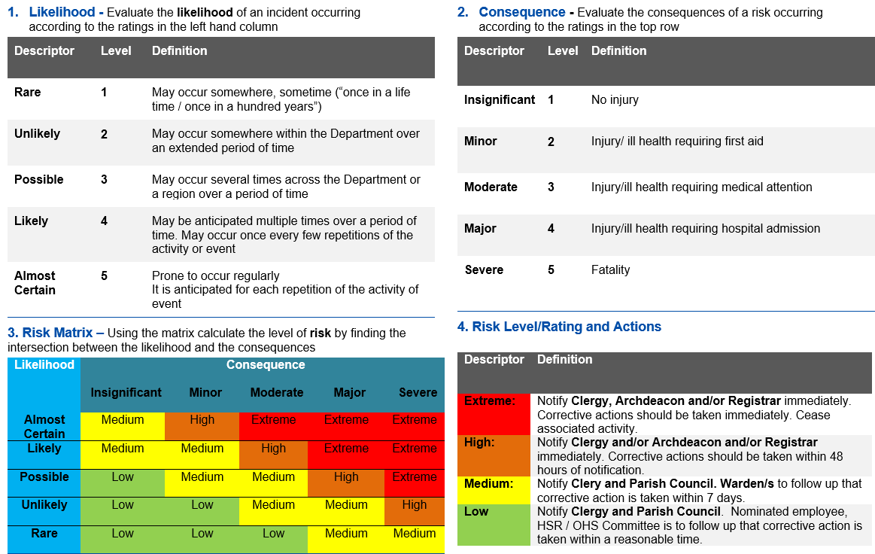
RISK RATING MATRIX

Our Diocesan Insurance Policy for Property and Excess
In 2020-2021 the excess for any property claim is $20,000. Of this individual parishes that make a claim are responsible for the first $5,000 of the excess.
The remaining $15,000 is paid from the Insurance Reserve, which every parish contributes to via their Insurance fees.
Below is the carrot and stick that our current building insurance premium includes.
For parishes who are able to demonstrate the below actions, you will not be charged the $5,000 excess in the event that you need to make an insurance claim.
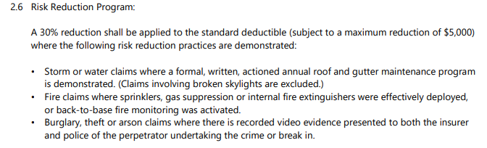

Please use this Church Property Report template & the Parish Annual Safety Inspection Template fully to ensure that you can demonstrate the above “risk reduction” and save your parish $5,000 if you need to make a claim in any of the areas covered above.

Consider when it can be budgeted for, eg the following year, or a future date 2022, 2023, as soon as funds can be raised (agree plan for raising funds)?

