PARISH - ANNUAL SAFETY INSPECTION CHECKLIST
‘Be careful then how you live, not as unwise people but as wise.’ Ephesians 5.15

In order to support the Parish to proactively manage risk, assist the Parish Council members to fulfil their obligations for “Duty of Care”, ensure people’s safety as far as possible and control future insurance costs the Template below is to be:
- completed and signed off on by the Parish Council (or subcommittee);
- presented to Parish Council ahead of budget deliberations for the following year (suggest September each year)
- forwarded to the Registrar by 31 October each year; and
- presented at the following Annual Parish Meeting.

Presented to Parish Council: ______ / ______ / ___________ (Date)
To be presented to Annual Parish Meeting: ______ / ______ / ___________
Sent to Registry: ______ / ______ / ___________

This form should be considered when developing the next year’s annual parish budget. Note that all issues identified DO NOT need to be addressed at once, create a plan to tackle the highest risks first.
Please take heart as this will take more time the first year that it is introduced, and it will be easier next time!

Parish/Centre |  | Year
Location of building
Name & position of person(s) completing this document
Not all issues identified need to be addressed at once, create a plan to tackle the highest risks first.
Inspection Item | Yes | No | N/A | Is there action to be taken?  If so, what action? Other Comments | Person(s) Responsible for taking action | When will action be taken? | Risk Rating
Access: Walkways & Flooring
Are all walkways, flooring and stairs free from slip or trip hazards?

Are entrances, exits, stairs & walkways clear from obstruction?

Are there exit signs & are they easily identifiable in an emergency?

Are there floor coverings & if so, what type and are they in good condition?

Is disabled access provided & if so, where (e.g. front door, rear door etc)

Is a ladder kept onsite?
Is the ladder used & for what reason?
General Electrical
Are plugs, sockets and switches in good condition? (i.e. undamaged)

Are all electrical items in use, (including power-boards, double adaptors and leads) regularly tested & tagged & how often?

General Lighting
Does the lighting allow you to move easily about the building & outside safely?

Air Quality
Is ventilation adequate, either natural, mechanical or air-conditioning system?

If in place, are air-conditioning and ventilation systems regularly serviced?

First Aid
Is there a first aid kit available & is it clearly marked and accessible?

Are the contents of the first aid cabinet clean, orderly, unopened and not past their use-by date?

Are emergency numbers clearly displayed at the kit?
Chemicals and cleaners
Are all chemicals & cleaners stored in domestic quantities?
Are all containers and bottles clearly & correctly labelled & marked?

Managing facilities and amenities
Is there safe access to toilet and wash-room facilities for all including disabled?

Are toilets cleaned & are consumables such as soap and hand towel replaced regularly?

Is any damage to plumbing, (inc. roof & gas plumbing) wiring & lighting dealt with promptly?

Is furniture in good safe condition?

Are stoves and fridges clean and in good condition & how old are these appliances?

Drinking water
Are there drinking water outlets available to all and are they separate from toilet and washroom facilities?

Site security
Are premises kept in good structural repair to prevent unauthorised entry and to keep the occupants safe?

If no to above, what repair works currently need to be undertaken?

Are there motion sensors or timed security lights etc?

Are the premises protected by an automatic alarm system, deadlocks and window locks?

Is key distribution restricted according to need & is a key list maintained?

Is there a safe and if so, are the keys kept offsite after hours?

Emergency Preparedness

Is there a written emergency plan covering relevant emergency situations with clear procedures?

Is the plan accessible to all and do all understand what to do in an emergency?
Is there a plan of the building with exits displayed?
Has someone with appropriate skills been made responsible for specific actions in an emergency?

Are emergency contact details relevant to the types of possible threats (e.g. fire, police, poison information centre) displayed in an easily accessible location?

Are contact details updated regularly?

Is there a mechanism (e.g. siren or bell alarm) for alerting all in the building to an emergency?
Is there a documented site plan that illustrates the location of fire protection equipment & emergency assembly points?

Are procedures in place for assisting the mobility impaired?

Is the fire protection equipment suitable for the types of risks, e.g. foam or dry powder type extinguishers?

Is equipment easily accessible in an emergency and is anyone trained to use it?

Are fire extinguishers regularly serviced and is this information updated regularly in your ESM manual?

Would you be able to advise neighbours in an emergency situation?

Are emergency evacuation drills undertaken to assess the effectiveness of your plan?
Is there someone who is responsible for
reviewing the plan?
Kitchen/pantry, food preparation areas and coffee stations

Are these areas regularly inspected by local health authorities?

Is there need for a vermin bating program?

Do food handlers maintain a high level of personal hygiene &
are the premises kept in a clean & tidy condition?

Op Shops (See Opp Shop Specific form)
Other
Is the ESM manual updated?
Signatures of reporters
Name Signature Date
__________________________ ________________________ ____/____/_____
__________________________ ________________________ ____/____/_____
__________________________ ________________________ ____/____/_____

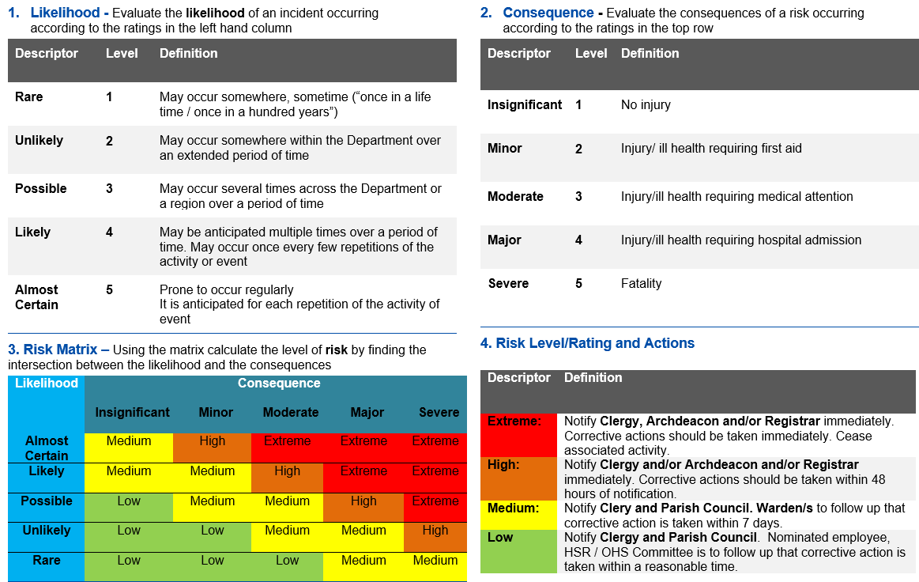
RISK RATING MATRIX

There is a Risk Matrix on page three to assist with Risk Ranking.

