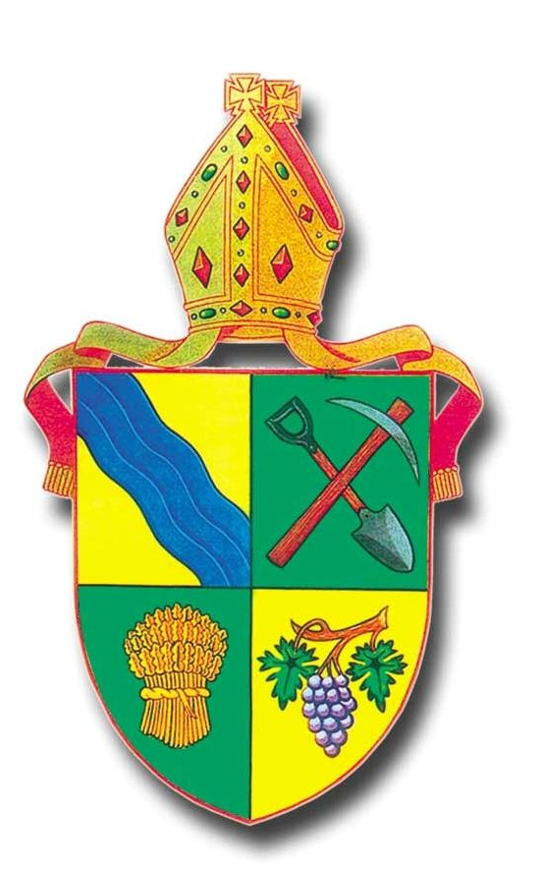

The
Bendigo
Eucharist

The Bendigo Eucharist is based on material from

Common Worship – Church of England 2002

and re-authorised for use in the Diocese of Bendigo

by the Bishop, August 2014

The Gathering

Please stand

Hymn

In the name of the Father,
and of the Son,
and of the Holy Spirit.
All: Amen.

The Greeting and Peace

The Lord be with you
All: and also with you.
We are the Body of Christ.
His Spirit is with us.
The Peace of the Lord be always with you
and also with you.

Prayer of Preparation

All: Almighty God,
to whom all hearts are open,
all desires known,
and from whom no secrets are hidden:
cleanse the thoughts of our hearts
by the inspiration of your Holy Spirit,
that we may perfectly love you,
and worthily magnify your holy name;
through Christ our Lord. Amen

Prayers of Penitence

Let us affirm our trust in God’s goodness and confess that we need forgiveness

All: Most merciful God,
Father of our Lord Jesus Christ,
we confess that we have sinned
in thought, word and deed.
We have not loved you with our whole heart.
We have not loved our neighbours as ourselves.
In your mercy
forgive what we have been,
help us to amend what we are,
and direct what we shall be;
that we may do justly,
love mercy,
and walk humbly with you, our God.
Amen.

or

Lord, we have sinned in thought, word and deed:
Lord have mercy
Lord have mercy

We are truly sorry and we ask you to forgive us:
Christ have mercy
Christ have mercy

Help us by your Spirit to live in newness of life:
Lord have mercy
Lord have mercy

Absolution

Almighty God,
who forgives all who truly repent,
have mercy upon you,
pardon and deliver you from all your sins,
confirm and strengthen you in all goodness,
and keep you in life eternal;
through Jesus Christ our Lord.

All: Amen.

The Gloria

Glory to God in the highest,
and peace to God’s people on earth.
Lord God, heavenly King,
almighty God and Father,
we worship you, we give you thanks,
we praise you for your glory.

Lord Jesus Christ only Son of the Father,
Lord God, Lamb of God,
you take away the sin of the world:
have mercy on us;
you are seated at the right hand of the Father:
receive our prayer.

For you alone are the Holy One,
you alone are the Lord,
you alone are the Most High, Jesus Christ,
with the Holy Spirit,
in the glory of God the Father. Amen.

The Collect

All: Amen.

Please sit.

The Liturgy of the Word

Readings

Two readings from Scripture usually precede the Gospel Reading.

At the end of each the reader says

This is the word of the Lord.
All: Thanks be to God.

Gospel Reading
Please stand

When the Gospel is announced the reader says

Hear the Gospel of our Lord Jesus Christ
According to N
All: Glory to you, Lord Jesus Christ

At the end

This is the Gospel of the Lord.
All: Praise to you, Lord Jesus Christ

Please sit

Sermon

The Creed

All: We believe in one God,
the Father, the Almighty,
maker of heaven and earth,
of all that is, seen and unseen.
We believe in one Lord, Jesus Christ,
the only Son of God,
eternally begotten of the Father,
God from God, Light from Light,
true God from true God,
begotten, not made,
of one Being with the Father,
through him all things were made.

For us and for our salvation
he came down from heaven,
was incarnate from the Holy Spirit
and the Virgin Mary
and became truly human.
For our sake he was crucified under Pontius Pilate;
he suffered death and was buried.
On the third day he rose again
in accordance with the Scriptures;
he ascended into heaven
and is seated at the right hand of the Father.

He will come again in glory to judge the living
and the dead,
and his kingdom will have no end.

We believe in the Holy Spirit,
the Lord, the giver of life,
who proceeds from the Father and the Son,
who with the Father and the Son is worshipped
and glorified,
who has spoken through the prophets.
We believe in one holy catholic and
apostolic Church.
We acknowledge one baptism for the forgiveness of sins.
We look for the resurrection of the dead,
and the life of the world to come.
Amen.

Or
Let us declare our faith in God:

We believe in God the Father,
from whom every family
in heaven and on earth is named.

We believe in God the Son,
who lives in our hearts through faith,
and fills us with his love.

We believe in God the Holy Spirit,
who strengthens us
with power from on high.

We believe in one God;
Father, Son and Holy Spirit. Amen. (Eph 3)

Prayers of Intercession

Let us pray for the world and the Church.

This response may be used

Lord, in your mercy

All: hear our prayer.

Ending with

Merciful Father,

All: accept these prayers
for the sake of your Son,
our Saviour Jesus Christ.
Amen.

The Liturgy of the Sacrament

Please stand

The Peace (if not used earlier)

To crown all things there must be love,
to bind all together and complete the whole.
Let the peace of Christ rule in our hearts.
cf Colossians 3:14

The peace of the Lord be always with you
All: and also with you.

Let us offer one another a sign of peace.

All may exchange a sign of peace

Preparation of the Table

The gifts of the people are taken and presented

(Hymn)

The table is prepared and the bread and wine are placed upon it

As the grain once scattered in the fields
and the grapes once dispersed on the hillside
are now reunited on this table in bread and wine, so, Lord, may your whole Church soon be gathered together
from the corners of the earth into your kingdom.

All: Amen.

The Eucharistic Prayer

The Lord be with you.
All: And also with you.

Lift up your hearts.
All: We lift them to the Lord.

Let us give thanks to the Lord our God.
All: It is right to give thanks and praise.

Blessed are you, Lord God,
our light and our salvation;
to you be glory and praise for ever.

From the beginning you have created all things
and all your works echo the silent music of your praise.
In the fullness of time you made us in your image,
the crown of all creation.

You give us breath and speech, that with angels and archangels and all the powers of heaven
we may find a voice to sing your praise:

All: Holy, holy, holy Lord,
God of power and might
heaven and earth are full
of your glory.
Hosanna in the highest

Blessed is he who comes
in the name of the Lord
Hosanna in the highest.

How wonderful are the works of your hands,
O Lord,
As a mother tenderly gathers her children,
you embraced a people as your own.
When they turned away and rebelled
your love remained steadfast.

From them you raised up Jesus our Saviour,
born of Mary,
to be the living bread,
in whom all our hungers are satisfied.

He offered his life for sinners,
and with a love stronger than death
he opened wide his arms on the cross.

Pour out your Holy Spirit as we bring before you these gifts of your creation;
may they be for us the body and blood
of your dear Son.

On the night before he died,
he came to supper with his friends
and, taking bread, he gave you thanks.
He broke it and gave it to them, saying:
Take, eat; this is my body which is given for you;
do this in remembrance of me.
At the end of supper, taking the cup of wine,
he gave you thanks, and said:
Drink this, all of you; this is my blood of the new covenant, which is shed for you and for many for the forgiveness of sins.
Do this, as often as you drink it, in remembrance of me.

All: Christ has died:
Christ is risen:
Christ will come again.

Father, we plead with confidence
his sacrifice made once for all upon the cross;
we remember his dying and rising in glory,
and we rejoice that he intercedes for us at your right hand.

As we eat and drink these holy things
in your presence,
form us in the likeness of Christ,
and build us into a living temple to your glory.
Remember, Lord, your Church in every land.
Reveal her unity, guard her faith,
and preserve her in peace.

Bring us at the last with [N and] all the saints
to the vision of that eternal splendour
for which you have created us;
through Jesus Christ, our Lord,
by whom, with whom, and in whom,
with all who stand before you in earth and heaven,
we worship you, Father almighty, in songs of everlasting praise:

All: Blessing and honour and glory and power
are yours for ever and ever.
Amen.

The Lord’s Prayer

As our Saviour taught us, so we pray:

All: Our Father in heaven,
hallowed be your name,
your kingdom come,
your will be done
on earth as in heaven.
Give us today our daily bread.
Forgive us our sins
as we forgive those who sin against us.
Save us from the time of trial
and deliver us from evil.
For the kingdom, the power,
and the glory are yours
now and for ever.
Amen.

Breaking of the Bread

The president breaks the consecrated bread

Every time we eat this bread
and drink this cup,

All: we proclaim the Lord’s death
until he comes.

The Agnes Dei may be included here or before the invitation to Communion*

Giving of Communion

The president says the invitation to communion

God’s holy gifts
for God’s holy people.

All: Jesus Christ is holy,
Jesus Christ is Lord,
to the glory of God the Father.

*Agnus Dei

Jesus, lamb of God,
have mercy on us

Jesus, bearer of our sins,
have mercy on us

Jesus, redeemer of the world,
grant us your peace.

The president and people receive communion.

Communicant members of all churches are welcome to receive communion here.

If you are not receiving communion and come forward for a blessing, please hold this order of service so that the priest knows your wishes.

To the words of distribution the communicant replies
Amen.

Prayer after Communion

Silence is kept

The Post Communion prayer is said

Living God
In this holy meal, you fill us with new hope.
May the power of your love,
which we have known in word and sacrament,
give us courage for our pilgrimage,
and bring us the joys you promise.

All: Amen.

Most loving God,
All: You send us into the world you love.
Give us grace to go thankfully and with courage
in the power of your Spirit.

The Dismissal

Please stand

Hymn

Blessing

The following or another blessing is said
God the Holy Trinity make you strong in faith
and love,
defend you on every side,
and guide you in truth and peace;
and the blessing of God almighty,
the Father, the Son, and the Holy Spirit,
be among you and remain with you always.

All: Amen.

Go in the light and peace of Christ.

All: Thanks be to God.

The ministers and people depart

