Churchwardens’ Annual Church Property Report
‘Go up to the hills and bring wood and build the house, so that I may take pleasure in it and be honoured, says the Lord.’ Haggai 1.

In accordance with The Parish Administration Act (2010) and good stewardship, the Template below is to be:
- completed and signed off on by the Churchwardens;
- presented to Parish Council ahead of budget deliberations for the following year (suggest September each year)
- forwarded to the Registrar by 31 October each year; and
- presented at the following Annual Parish Meeting.

Presented to Parish Council: ______ / ______ / ___________ (Date)
To be presented to Annual Parish Meeting: ______ / ______ / ___________
Sent to Registry: ______ / ______ / ___________

This form should be considered when developing the next year’s annual parish budget. Note that all issues identified DO NOT need to be addressed at once, create a plan to tackle the highest risks first.

Please take heart as this will take more time the first year that it is introduced, and it will be easier next time!
Parish/Centre |  | Year
Street address
Building

Complete visual inspection and tick / insert comments or rating where appropriate
(one report per building):

External
 | No visible problem | Further Inspection Required | Work to be undertaken | When will action be taken? | Risk rating
Roof
Guttering
Windows / Doors
Walls
Ground level perimeter
Steps/Ramps/Handrails
Land and gardens
Other (eg garden)
Other

Internal
 | No visible problem | Further Inspection Required | Work to be undertaken | When will action be taken? | Risk rating
Ceiling
Walls
Windows / Doors
Floor / Flooring
Furniture
Handrails
Other (eg handbasin)
Other -

Notes: Nature of required work: ____________________________________________________________________________________________________
Notes: Timeline of required work:___________________________________________________________________________________________________
Churchwardens Signatures
Name Signature Date
__________________________ ________________________ ____/____/_____
__________________________ ________________________ ____/____/_____
__________________________ ________________________ ____/____/_____
Provision in Parish Budget: Yes / No (Year:__________)

Estimated Cost of work required: ___________________

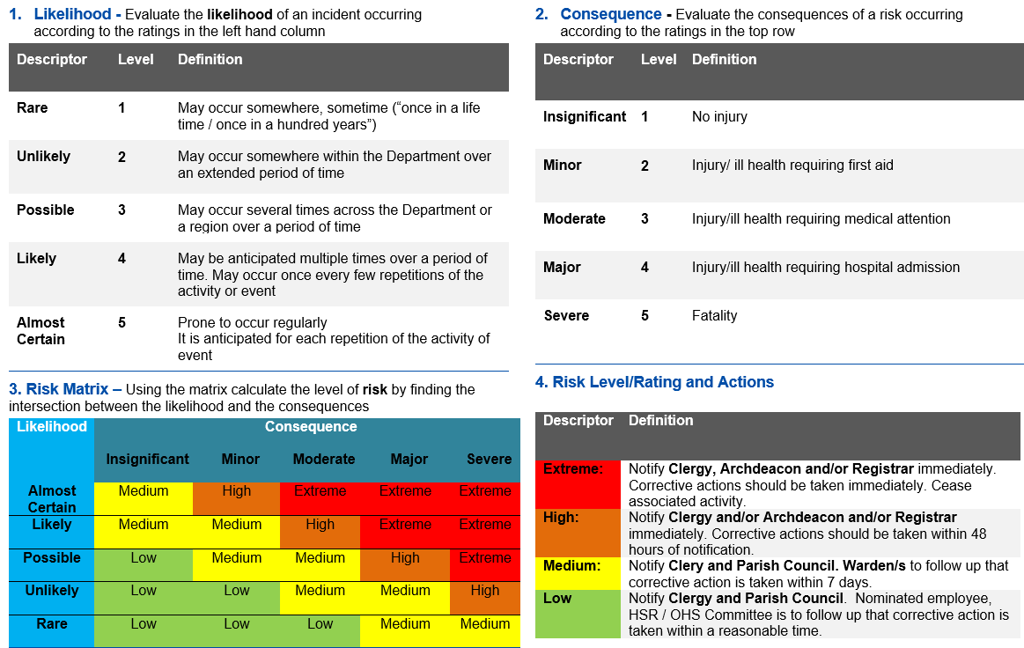
RISK RATING MATRIX

There is a Risk Matrix on page three to assist with Risk Ranking.
Consider when it can be budgeted for, eg the following year, or a future date 2021, 2022, as soon as funds can be raised (agree plan for raising funds)?

