**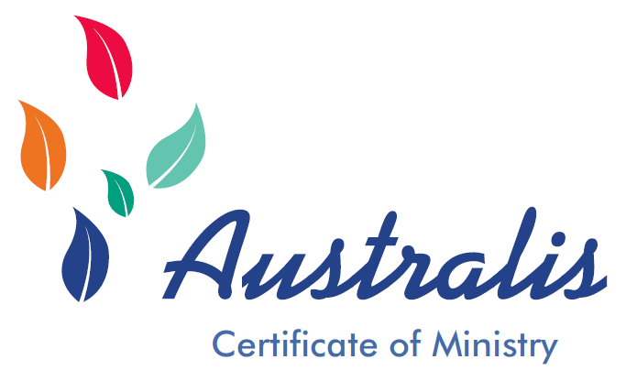 *Growing your ministry, faith, and discipleship   
in a vibrant, local   
learning community.***

# **Learning Communities around Bible, Church and Mission**

The Australis Certificate of Ministry equips people to reflect on their faith, ministry and discipleship in the context of their everyday lives as part of a community of learners.

There are six study units in the course. Units are conducted in small groups facilitated by a qualified tutor. The Bendigo Anglican Diocese awards the Australis Certificate of Ministry to students who complete the six units of study.

The course was originally developed by the Diocese of Lichfield Board of Ministry. It was brought to Australia by Bishop Andrew Curnow of Bendigo, where it was edited and contextualised by Dr Charles Sherlock and administered by Trinity Theological School (Melbourne). It was known as the Trinity Certificate for sixteen years before the Anglican Diocese of Bendigo took responsibility for the next phase in its development.

To date, more than 1,000 people in the dioceses of North Queensland, Brisbane, Sydney, Bathurst, Wangaratta, Bendigo, Ballarat, Melbourne and New Zealand have completed one or more of these units towards the certificate. A number of regions are using the Certificate as part of their preparation of candidates for Local Ordained Ministry.

# **Australis Certificate of Ministry Units**

1. Experiencing Christian Faith: How do we experience Christian faith through praying, using the Bible, singing, worship, story and discipleship?

2. User’s Guide to the Old Testament: How do stories, wisdom and instructions from the distant past help us to live as God’s people in twenty first century Australia.

3. User’s Guide to the New Testament: Learning from the beginnings of Christianity about believing, worshipping and living as God’s people today.

4. The Anglican Church – Our Story: Explore how the Christian gospel reached the British Isles, how the Church of England was formed and how the Anglican Church has influenced Australia’s history.

5. Confessing our Faith: What do I believe and how can I express my faith more clearly?

6. Serving Christ Today: How do we live as disciples of Jesus Christ in our lifestyle, mission, stewardship and calling?

7. Performing the Gospel: Worshipping God in Liturgy and Lifestyle.

Each unit in the Certificate includes 8 or 9 sessions, involving 16 to 20 class workshop hours in total, and requiring a similar period of preparation time.

To be awarded the Australis Certificate, students must complete at least 6 units, comprising Units 1,2,3,5 and any 2 of Units 4, 6 and 7. Successful completion of each unit involves attending and participating in a minimum of 80 per cent of classes and completing an assessment task (essay, journal, or creative work such as art or poetry) equivalent to an essay of 1,200–1,500 words.

Students or groups are also welcome to take individual units of particular interest without progressing toward the Certificate.

# **Who is the Certificate designed for?**

The Certificate course is ideal for anybody who wishes to learn about and deepen their faith. Current students include:

* Christians wishing to explore issues of faith and church
* people involved in worship and music ministries
* retirees who wish to study in new leisure time
* people testing their vocation
* members of parish pastoral teams
* people engaged in Church agencies and welfare organisations.

Australis Certificate has an Australian Anglican “flavour”, most obvious in Units 4 and 7 but present throughout. Students from all backgrounds who can sit comfortably with that perspective are welcome and are never expected or required to agree. Spirited discussion is always encouraged!

# **Certificate Costs**

Each participant pays $65 per unit. This covers the price of the workbook for each unit and supports the administration and updating of the course. GST will be added to invoices for individuals or organisations outside the Anglican Church. Orders sent outside Australia do not attract GST, however the destination country may impose taxes. The unit tutor is entitled to one complimentary copy of the workbook.

# **Contact**

Please email the Australis Certificate in Ministry administrator on [admin@bendigoanglican.org.au](mailto:admin@bendigoanglican.org.au) for more information.