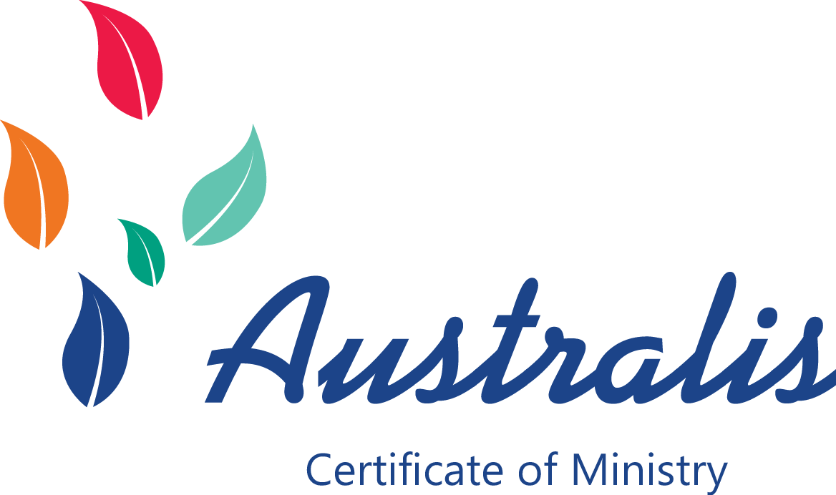 ***Growing your ministry, faith, and discipleship   
in a vibrant, local   
learning community.***

# **Getting Started – for Ministers and Tutors**

The Australis Certificate of Ministry empowers you to teach and train your parish members with minimal preparation time. Everything has been prepared for you. The Facilitator Manual (available on the web site) helps you to think through your role as a facilitator.

Let your congregation know the course will be starting soon. Consider inviting other local churches to participate if you have small numbers from your parish. Download and distribute the brochures and fliers on the Australis web site.

Alert your church members about the advantages of this form of study:

* Parish based. Working through this course together will support the ministry of your parish by enhancing community and co-operation while building members’ confidence in handling the Bible and articulating their faith. A strength of this course is its emphasis on interactive education, hearing other perspectives and learning from each other.
* Solid training in Bible, church and ministry from a broad Anglican perspective.
* Accessible education without being too academically challenging. It is for everyone wanting a better grounding in Christian faith and practice. It does not take a specific perspective on theology or churchmanship and will enable each student to appreciate the perspectives of others.
* Used in Preparation for ministry in the Anglican Church for lay people and for ordained local ministers (OLM’s). Consult your bishop about OLM training as this varies between dioceses.
* 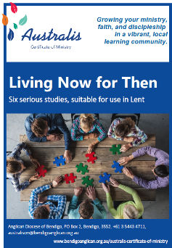Used throughout Australia and New Zealand. More than 1,000 people have enriched their understanding and practice of their faith by studying this course together.

Consider starting with a “tasting plate” by using *Living Now For Then* for your Lenten or Advent studies. This six-week series gives your church members a sample of each of the Australis units and introduces them to the format of Australis study. Email the administrator for a PDF of these studies that you can print for your group.

Decide how much time you can give to your group. Will classes be weekly, fortnightly or monthly? It is up to you. Each unit covers eight or nine sessions. Each session will take about two hours. You will also need to allocate time for marking the assessment tasks.

Decide which unit to begin with. There are advantages to working through the subjects in order, but if your group has a strong interest in studying the New Testament, there is nothing to stop you from starting at Unit 3. You might even decide to run two or three units at once.

Once you have settled on class times and student numbers, contact the academic administrator about enrolling the students and ordering course books. Order your workbooks at least two weeks before you plan to start (more in remote areas) to ensure that they will get to you on time.

# **Getting Started – for Students**

The Australis Certificate provides a framework that enables learning to happen through group discussion and interaction. When you decide to study this way, the first thing to do is find out if there is a group nearby or else start exploring the possibility of getting a group started at your church. You can email the administrator to find out about groups near you.

If you would like to study the Australis Certificate in your church, talk with your minister or other church leader about your desire to study. Give them some information about Australis and tell them you would appreciate having them as tutor. (Australis tutors need to have some theological training and some experience facilitating group discussions. Most ministers would be perfect.) Show them how to find the Tutor’s Manual on the web site.

Most ministers are busy and may need a few months’ notice before getting a group started. This will give you time to invite others to join in.

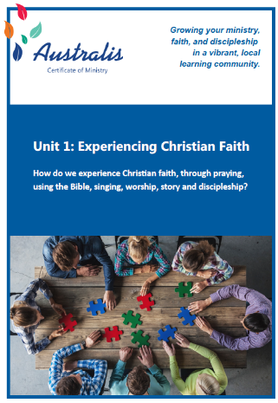Talk to your friends and congregation members about your interest in the course. Tell them how much you would love to have them study with you. Invite widely, and don’t make assumptions about who might be interested. This course is for everyone! Offer to work with your church leaders to make posters, flyers and announcements to encourage people to join the group. You are welcome to use any of the material on the web site. Some flyers there have space so you can add your own details.

Consider your ability to commit time to the course. Each lesson requires a few hours of reading and preparation, and an assessment task is to be completed for each Unit. Assessments may be in the form of creative projects, personal reflection papers or academic essays. You will be given a selection of assessments to choose between.

# **Contact**

For enrolments, orders, and any questions, contact the Australis Certificate of Ministry Administrator on [admin@bendigoanglican.org.au](mailto:admin@bendigoanglican.org.au).